**“Experiment 2.3”**

Student Name: **SUMIT KUMAR** UID: **20BCS8226**

Branch: **CSE** Section/Group: **808 A**

Semester: **5** Date of Submission: **28-10-22**

Subject Name: **Multimedia Technologies Lab**  Subject Code: **20CSP-339**

**1. Aim/Overview of the practical:**

Import two pictures, one that of the sea and another of clouds. Morph, Merge and overlap the images using photopea.

**2. Which logistics used:**

Hardware Requirements: - Minimum 384MB RAM, 100 GB hard Disk, processor with 2.1 MHz

Software Requirements: - Photopea

**3. Steps for experiment/practical/Code:**

**Step 1:** Create new project on Photopea, and specify dimensions as required.

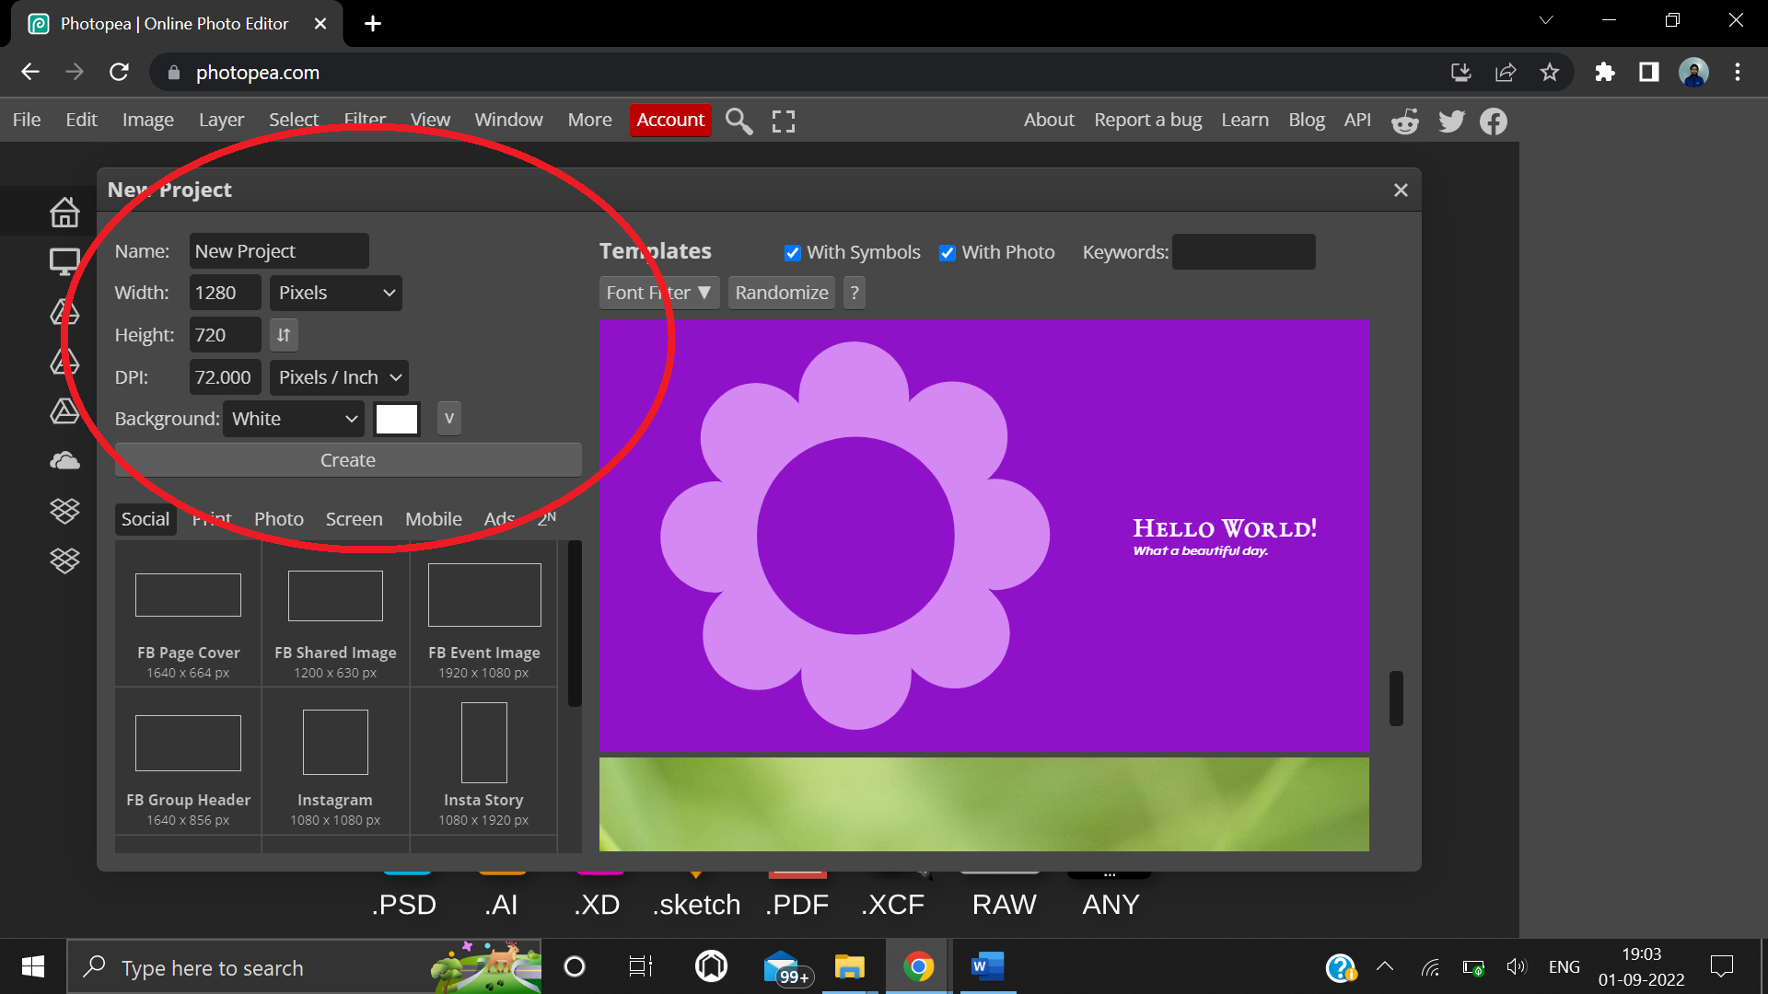

**Step 2:** Copy an image of clouds from google and paste on the screen.

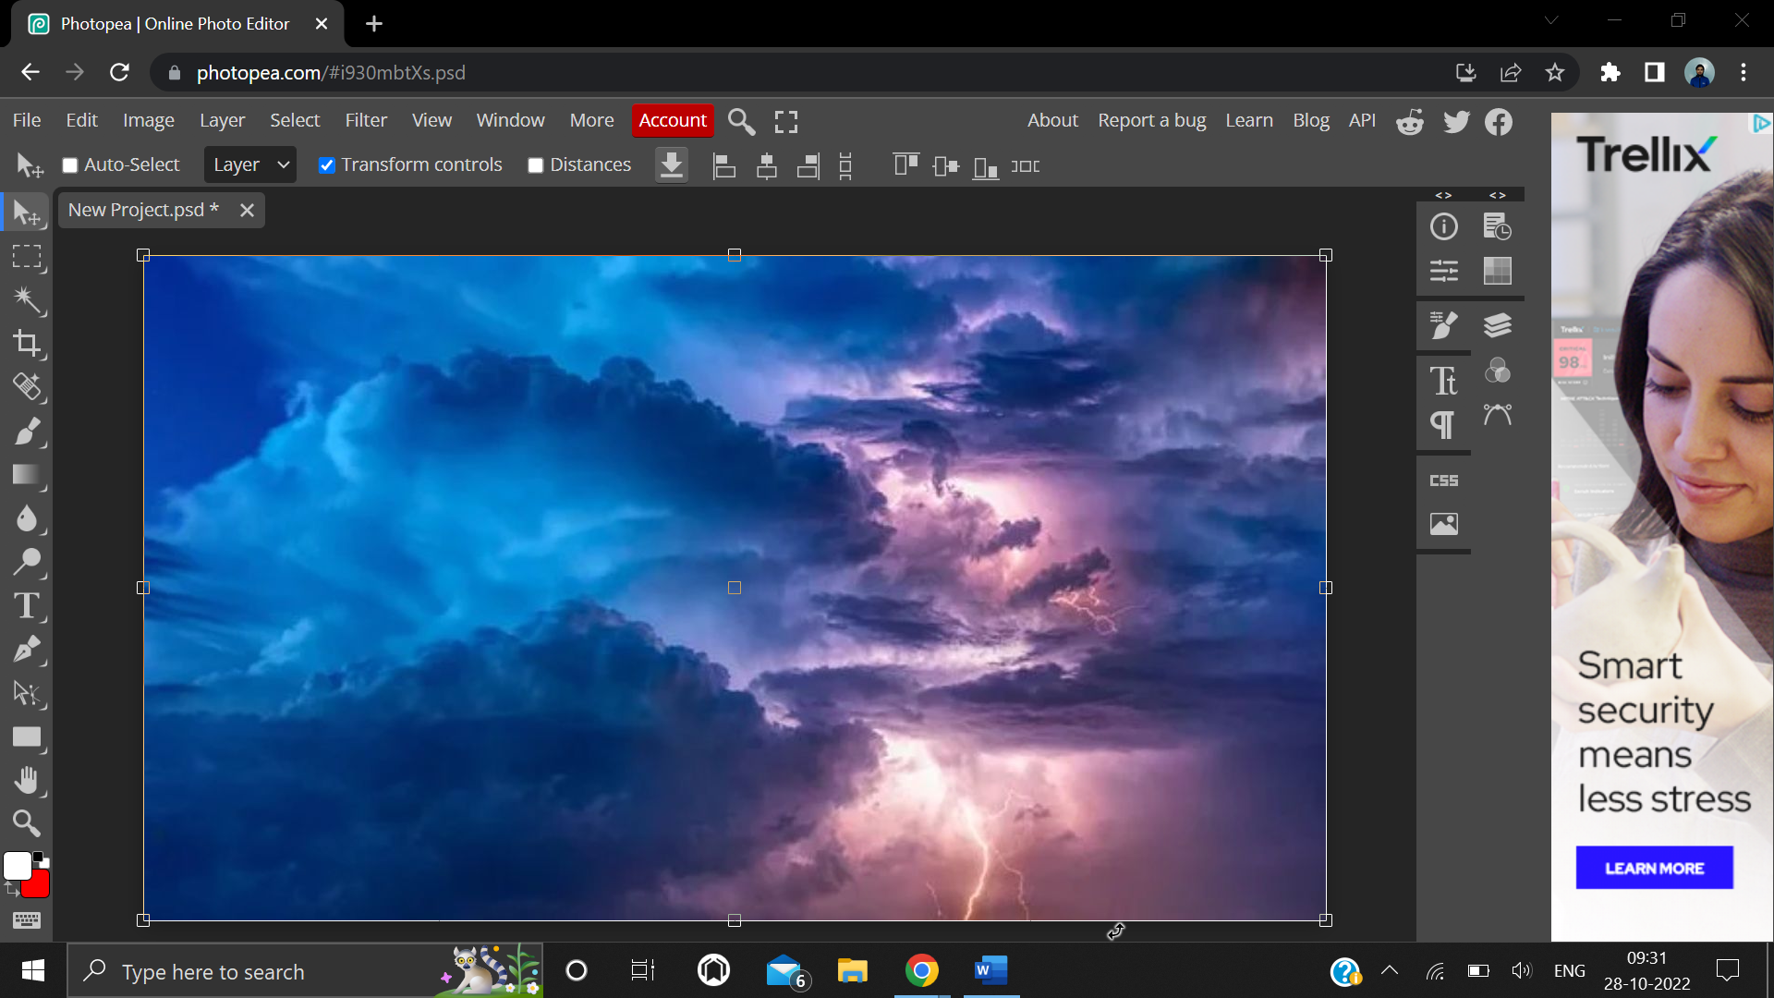

**Step 3:** Now, paste the second background image of sea over the first image.

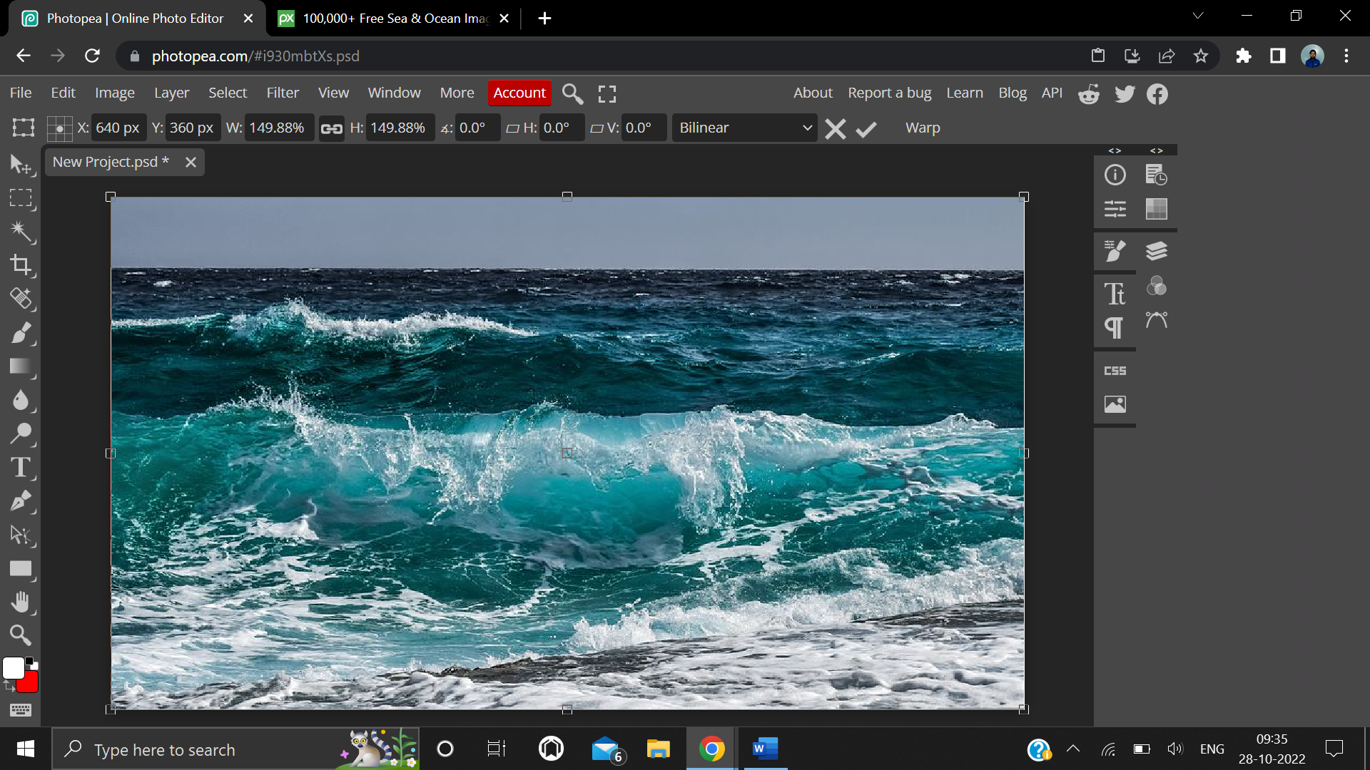

**Step 4:** Go to Layer -> Raster Mask -> Add (Reveal All).

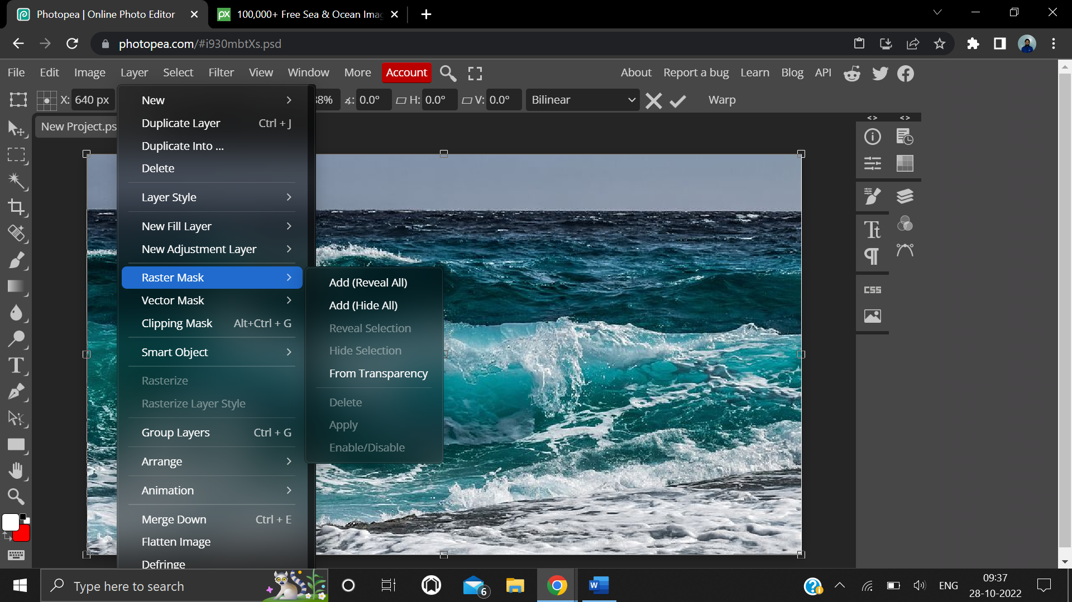

**Step 5:** Now select the Gradient Tool (G) from side bar. Select black and white gradient from the options.

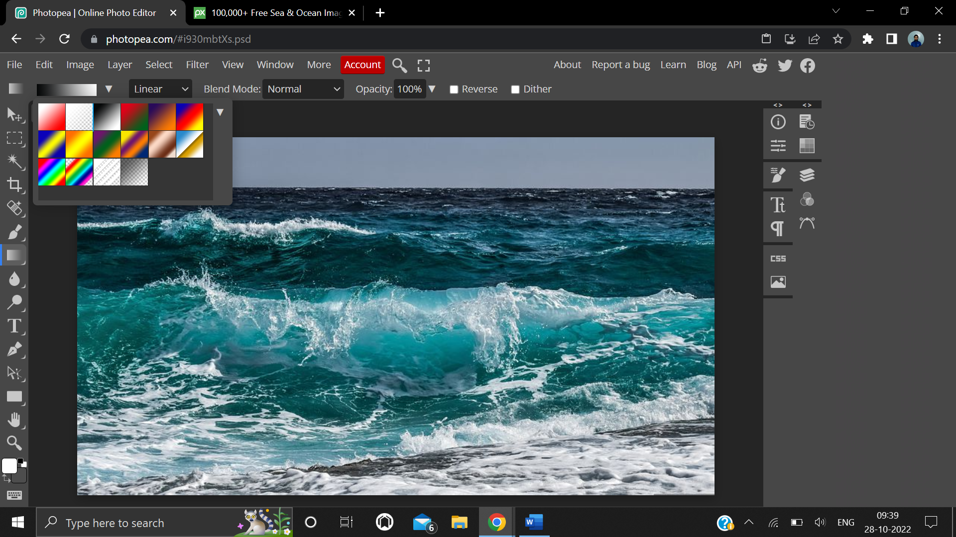

**Step 6:** Now drag the line accordingly to merge the two photos as you seem good.

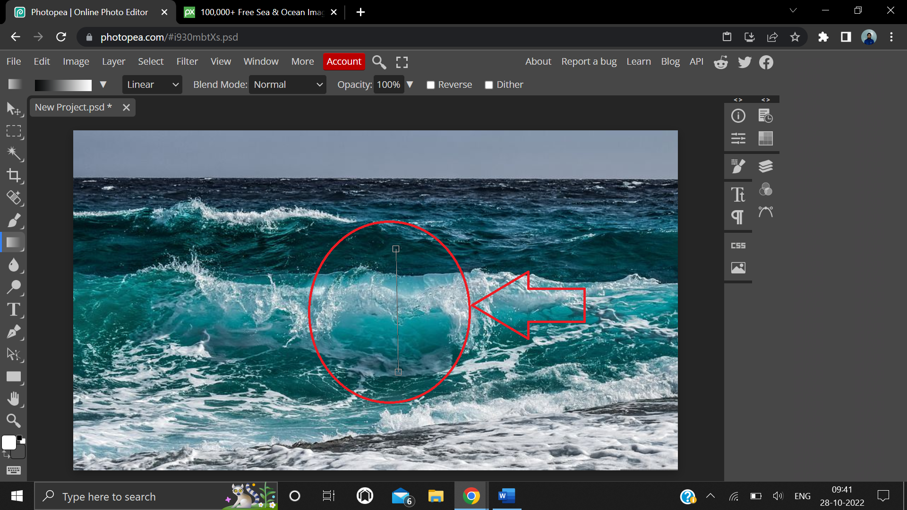

**Step 7:** Now, both the images are merged successfully.

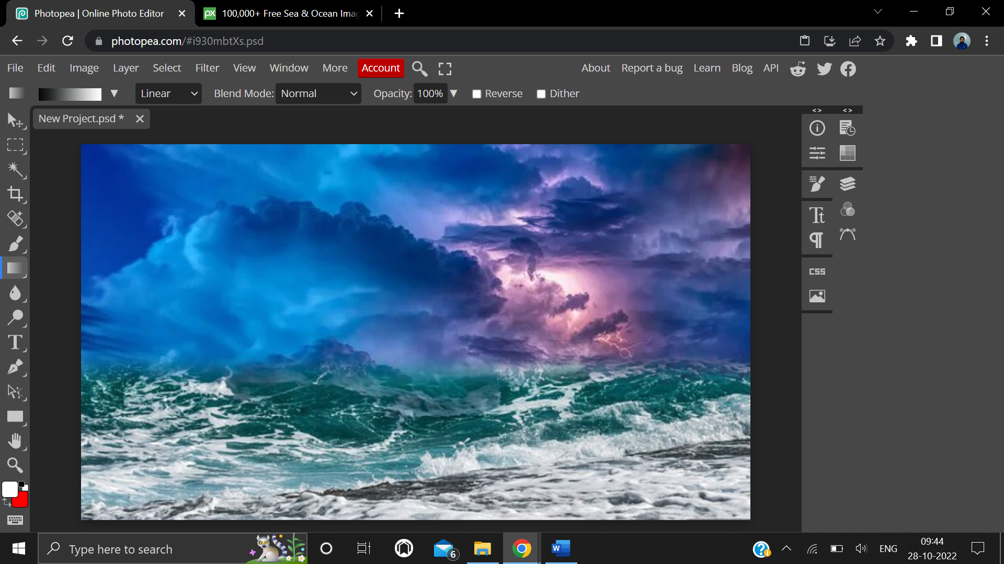

**4. Result/Output/Writing Summary:**



**Learning outcomes (What I have learnt):**

**1.** Learnt different functions / features of Layer option on Photopea.

**2.** Learnt about the gradient and different options present in gradient.

**3.** Learnt how to use black and white gradient.

**4.** Learnt how to merge two images.

**Evaluation Grid (To be created as per the SOP and Assessment guidelines by the faculty):**

|  |  |  |  |
| --- | --- | --- | --- |
| Sr. No. | Parameters | Marks Obtained | Maximum Marks |
| 1. |  |  |  |
| 2. |  |  |  |
| 3. |  |  |  |
|  |  |  |  |